Foster Lake (Wright County) Carp Meeting Monday, April 22, 2011

How Rice Lake became involved
Jim Krause from the Foster Lake Association (see Exhibit A) contacted us through the RLAA website after reading up on our experiences with carp and bullhead. Jim noticed some similarities in how their shallow lake was impacted by the presence of rough fish to the point where they had little vegetation growth at all.
Jim asked if he could meet with anyone from the RLAA board to discuss their lake issues and see if we could help each other out to accomplish our goals of improving water quality by reducing the rough fish population.

Brief History on Foster Lake
Foster Lake (see Exhibit B) is a small, shallow 120 acre private (no public access) lake located near Rogers, MN. FLA is made up of just a few shoreline homeowners (about 1/3 the amount of Rice Lake) where much of the shoreline is owned by local government entities. They have worked with local farms in the are to improve the quality of the water coming into the lake over the past several years and are confident they are not introducing more nutrients into their water body.
Season algae levels in the lake are severe, with the average phosphorous levels over 250 ppb. There was very little vegetation in the lake since the early 2000's, mostly due to the low water clarity caused by the heavy concentrations of nutrients which shielded the sun from allowing the plants to grow. Secchi disk readings averaged less than 1.5' during the summer months.
In 2007 the lake association decided to treat the lake with alum, to reduce the algae levels by absorbing the phosphorous. The got quotes from Lake Restoration (Rogers) to do the alum treatments at over $50,000; they decided to purchase the chemicals at a cost of $20,000 and do the application themselves over a 3-year period by applying 1/3 of the dosage each of the 3 years.
Beginning in 2008 they began to see significant reductions in the levels of phosphorous in the lake (from 450 ppb down to less then 200 ppb), and in 2009 even a further reduction (down to 160 ppb). (See Exhibit C) After the 3rd year of alum treatment in 2010, the phosphorous level actually increased (from 160 to 185 ppb). (See Exhibit D) The consensus for this increase is thought to be the presence of too many rough fish (both carp and bullhead). (Note: The goal for lakes in that area is less then 96 ppb (nearby lakes average between 20-50 ppb).)
Vegetation (primarily coontail) began showing up out to 2' in depth in 2008, extending to 4' in 2009. However, there was not much of an increase in growth in 2010, which supported the assumption that other factors (rough fish) were disrupting the growth of native vegetation.

Discussion and Comparisons between the lakes
Bill Kidder and George Schneider met with Jim Krause on Monday, April 11 at Byrleys to compare notes from our lakes and see what options existed for improving each of our lakes. Jim was very interested in the results we got from our Carp Enclosure study, which confirmed the absence of fish increased the growth of vegetation.
The Foster Lake Association is currently in discussions with Jeff Riedemann from Riedmann Fisheries to plan on netting carp during the open water season. Jeff had stated to them they could essentially remove the carp for no cost to them, assuming the market price is acceptable. Since they would be removing the carp during the open-water season, they would need to build a containment pen in the lake to hold the fish. They would then remove the fish closer to the ideal market period (late fall) for delivery to the consumers. Removal of the bullhead would be done at any time during the open water season and they would be hauled away to local farmers to be used as fertilizer. At this point, no contact has been signed with Jeff, but they are interested in taking some action this year with him to remove the carp.

Next Steps
Both RLAA and FLA will keep in touch regarding any upcoming action to compare notes to find out what works best for each of our lakes. Foster Lake is not listed as 'Impaired' since they have not been surveyed up to this point. They will be contacting the Minnesota Pollution Control Agency to provide data so they can be listed and follow the required TMDL Project Plan process.

Exhibit A
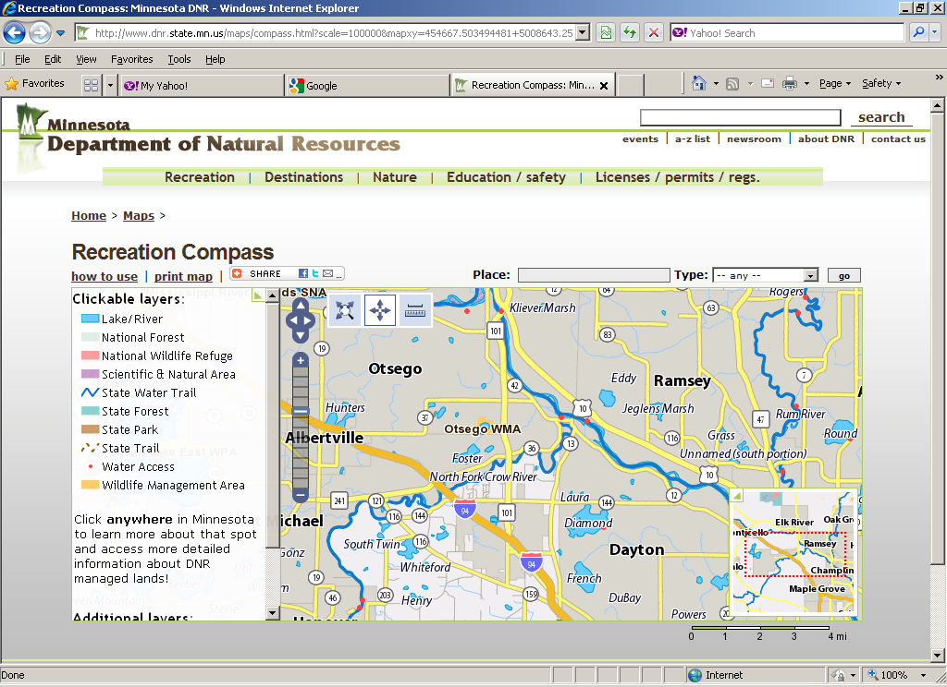

Exhibit B
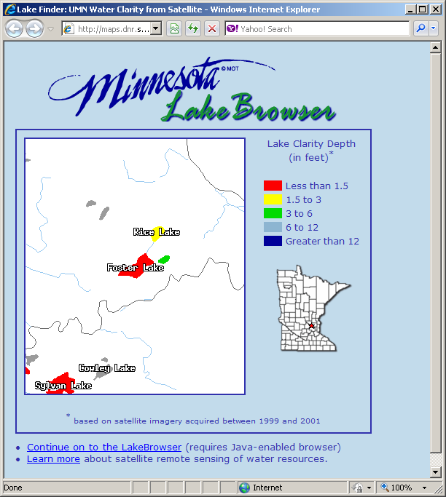
Exhibit C
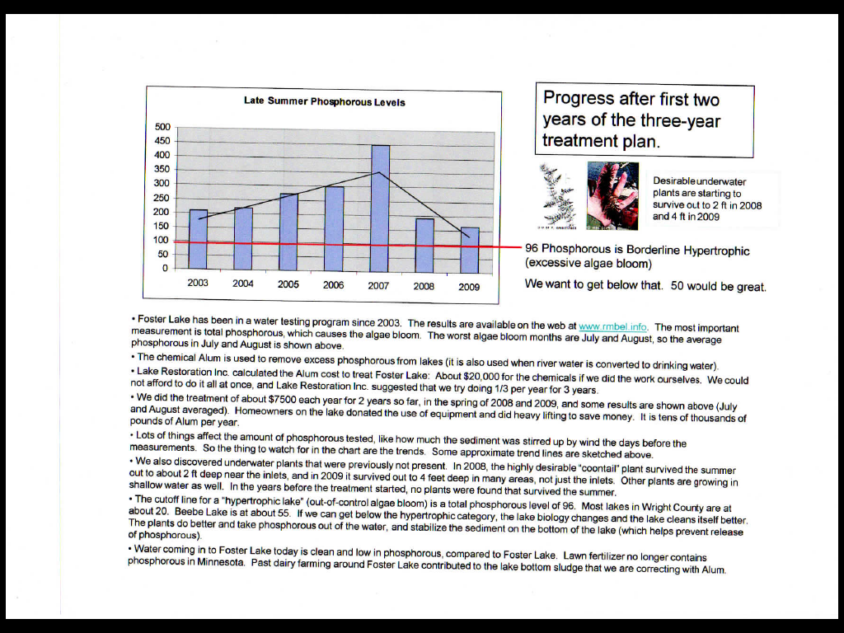

Exhibit D
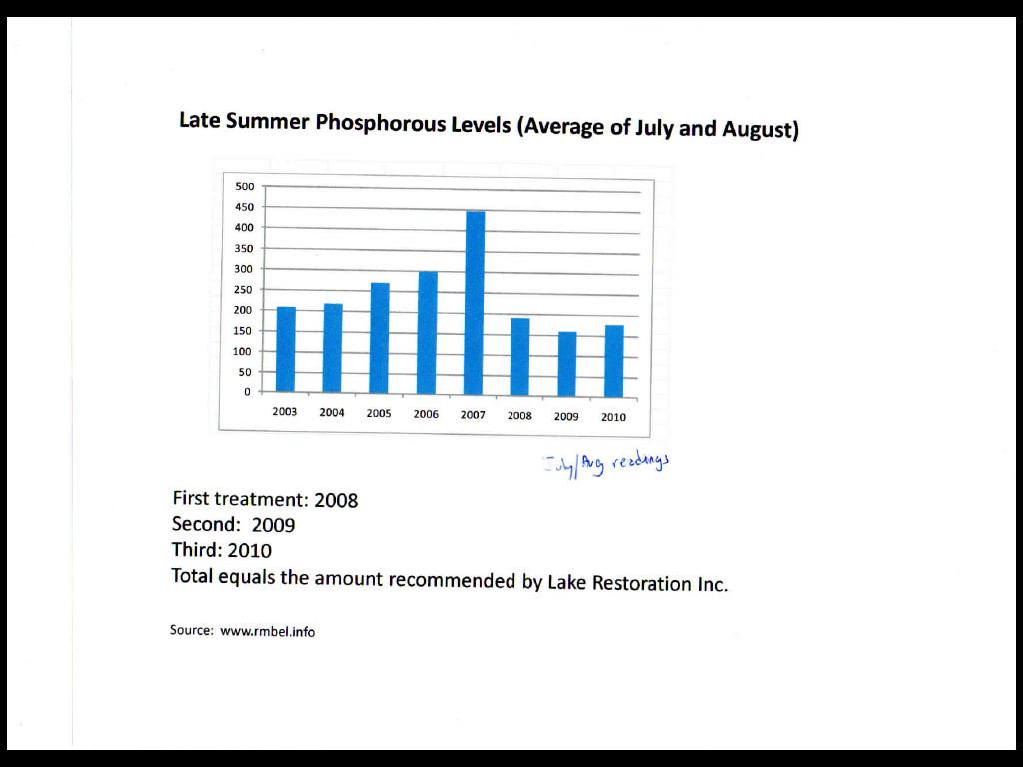

Summary written by George Schneider (RLAA)
4/16/2011

