Fall 2011
Rice Lake Newsletter

A non-profit organization serving the members of Rice Lake Area Association (RLAA)
RLAA Member Appreciation

We would like to extend a big 'Thank You' to those of you who have helped support RLAA by paying your association dues. As part of that recognition, we would like to invite you to attend a Bowling Banquet at Sundance Golf & Bowl this winter (details will be coming your way in a formal invitation to those of you who have contributed by paying 2011 RLAA dues).

Mark & Lori Ellingson Scott & Joy Roeglin
Dick & Joyce Drangeid Dan & Sue Hanson
Joe & Susie Liedl Jim & Anne Marie Seward
Jami Stromberg Robert Nelson & Kathleen O'Brien
Paul & Jennipher Mattson Bill & Marie Kidder
Shane & Enid Mason Don & Biddy Waletzko
Peter & Sharon Raatikka Cheryl Flegel
Robert & Eileen Youds William & Vicki Blincoe
Allen & Pat Chan Tom & Michelle Schmidt
David Johnson & Debbra Davis Will & Erin Swanson
Mark & Jean Pogemiller Jill Avery
Wade & Rebecca Quale Jerry & Mary Yunger
Russ & Nika Rybinski Larry & Ann Bick
Gary & Shawna Shubinsky Tim & Denise Zastoupil
Mark & Leslie Davison Randy & Leanne Forbrook
Robert & Amber Shimpa Chuck & Pat Berger
Jeff & Mary Ellen Swanson Marlin & Sarah Grose
Richard & Linda Hibbard Tim George
Michelle Cortez Tristan Bay Homeowners Assoc.
George & Jana Schneider Jim & Carol Malone
Bob & Sue Drag Dale Weick
Crystal Larson Maple Grove Free Evangical Church
Richard & Joni Stulac Lyle & Gail Shank
Marshal & Lisa Alsaker Thomas & Laura Donnelly
Jim & Molly Kridel

Special Interest Articles:

• RLAA Member Appreciation

- Fish Kill in Elm Creek (north) Aug 30-31

- RLAA 2011 Member Survey results

- Elm Creek TMDL update

- The Green Section (see separate insert from Gertens)

Individual Highlights:
PROJECT UPDATE 2
TREASURY REPORT 2
GREEN SECTION 3
(see insert)
FEATURE ARTICLE 3
OTHER LOCAL LAKES 4
WEBSITE STATS 4
WANT ADS 4
CONTACT INFO 4
Next Board Meeting

When:
November/December
(to be determined)

Where: Maple Grove Library
(Conference Room #105)

Visit our website for agenda and please RSVP your attendance!
RLAA Committees/Task Teams seek more members!!
Join one of our association committees and help determine the future of our lake/creek.
- Membership Team
- Lake Management Team
- Environmental Team

If you would like to be a part of one of these teams, contact us at RiceLakeAssoc@comcast.net.
2011 Spring Survey Results
Thanks to those of you who participated in the RLAA Survey we distributed earlier this year. We received a total of 35 responses from over 250 surveys we sent out via e-mail, US Mail or the Internet. Your input will help us determine our priorities as we move forward in our efforts to improve the quality of our lake.
Congratulations to the winner of the drawing for a $50 gift card for Red Lobster, Shane & Enid Mason!
For complete details on the survey, visit our website page at: http://ricelake.homestead.com/files/RLAA_Survey_2011_RESULTS_Web_Version_with_comments.mht.

Navigation Buoy Installation
Undertaken by RLAA Board of Directors

Project Objectives:
Address the concerns raised by several residents who report boaters speeding close to the shoreline, especially near narrow channel entrances into bays and creeks.
The RLAA Board of Directors agreed that professional navigation buoys with 'Slow No Wake' signage were necessary to be posted at the key areas where complaints about speeding had been reported - by the Boat Ramp Bay and where Elm Creek exits Rice Lake on the NE end.

Project Results
Scott Roeglin ordered three (3) buoys from Rolyan Buoys in Cedarburg, WI at a total of $361.52. Rick Stulac created 100+ lb concrete anchors for each of the buoys.
On June 25th, several board members went out by pontoon boat to set the anchors in locations 150' from the shorelines.
On October 1st, several of the same board members removed the 3 navigation buoys for the winter. Their anchors were left in the water with small fender buoys denoting those locations so the buoys can be placed in the same spots next season.

Project Feedback
Several residents have sent positive complements to RLAA stating the buoys were a positive step in reducing speeding occurrences on the lake/creek.

For more info, visit RLAA Website 'Other Activities' page at this link: http://ricelake.homestead.com/files/Buoy_Installation_with_photos.mht

2011 Plant Update
Although a formal plant survey was not conducted in 2011, visual observations by residents have indicated a slow increase in the number of both native (good) and non-native (bad) plants.
Some residents observed a slight increase of Curlyleaf Pondweed (non-native) this spring, but it was not deemed enough to warrant any treatment.
Native plant growth, especially of Coontail, was dominant in the West Bay of the lake again in 2011, making navigation difficult when almost 100% of the surface was covered.

Project Update

Since our last media communication (the Annual Meeting Minutes), RLAA has completed one project to purchase and set up navigation buoys at two locations where some boaters tended to speed. See below for details.

Update by George Schneider

Rick Stulac prepares the next buoy for launching.
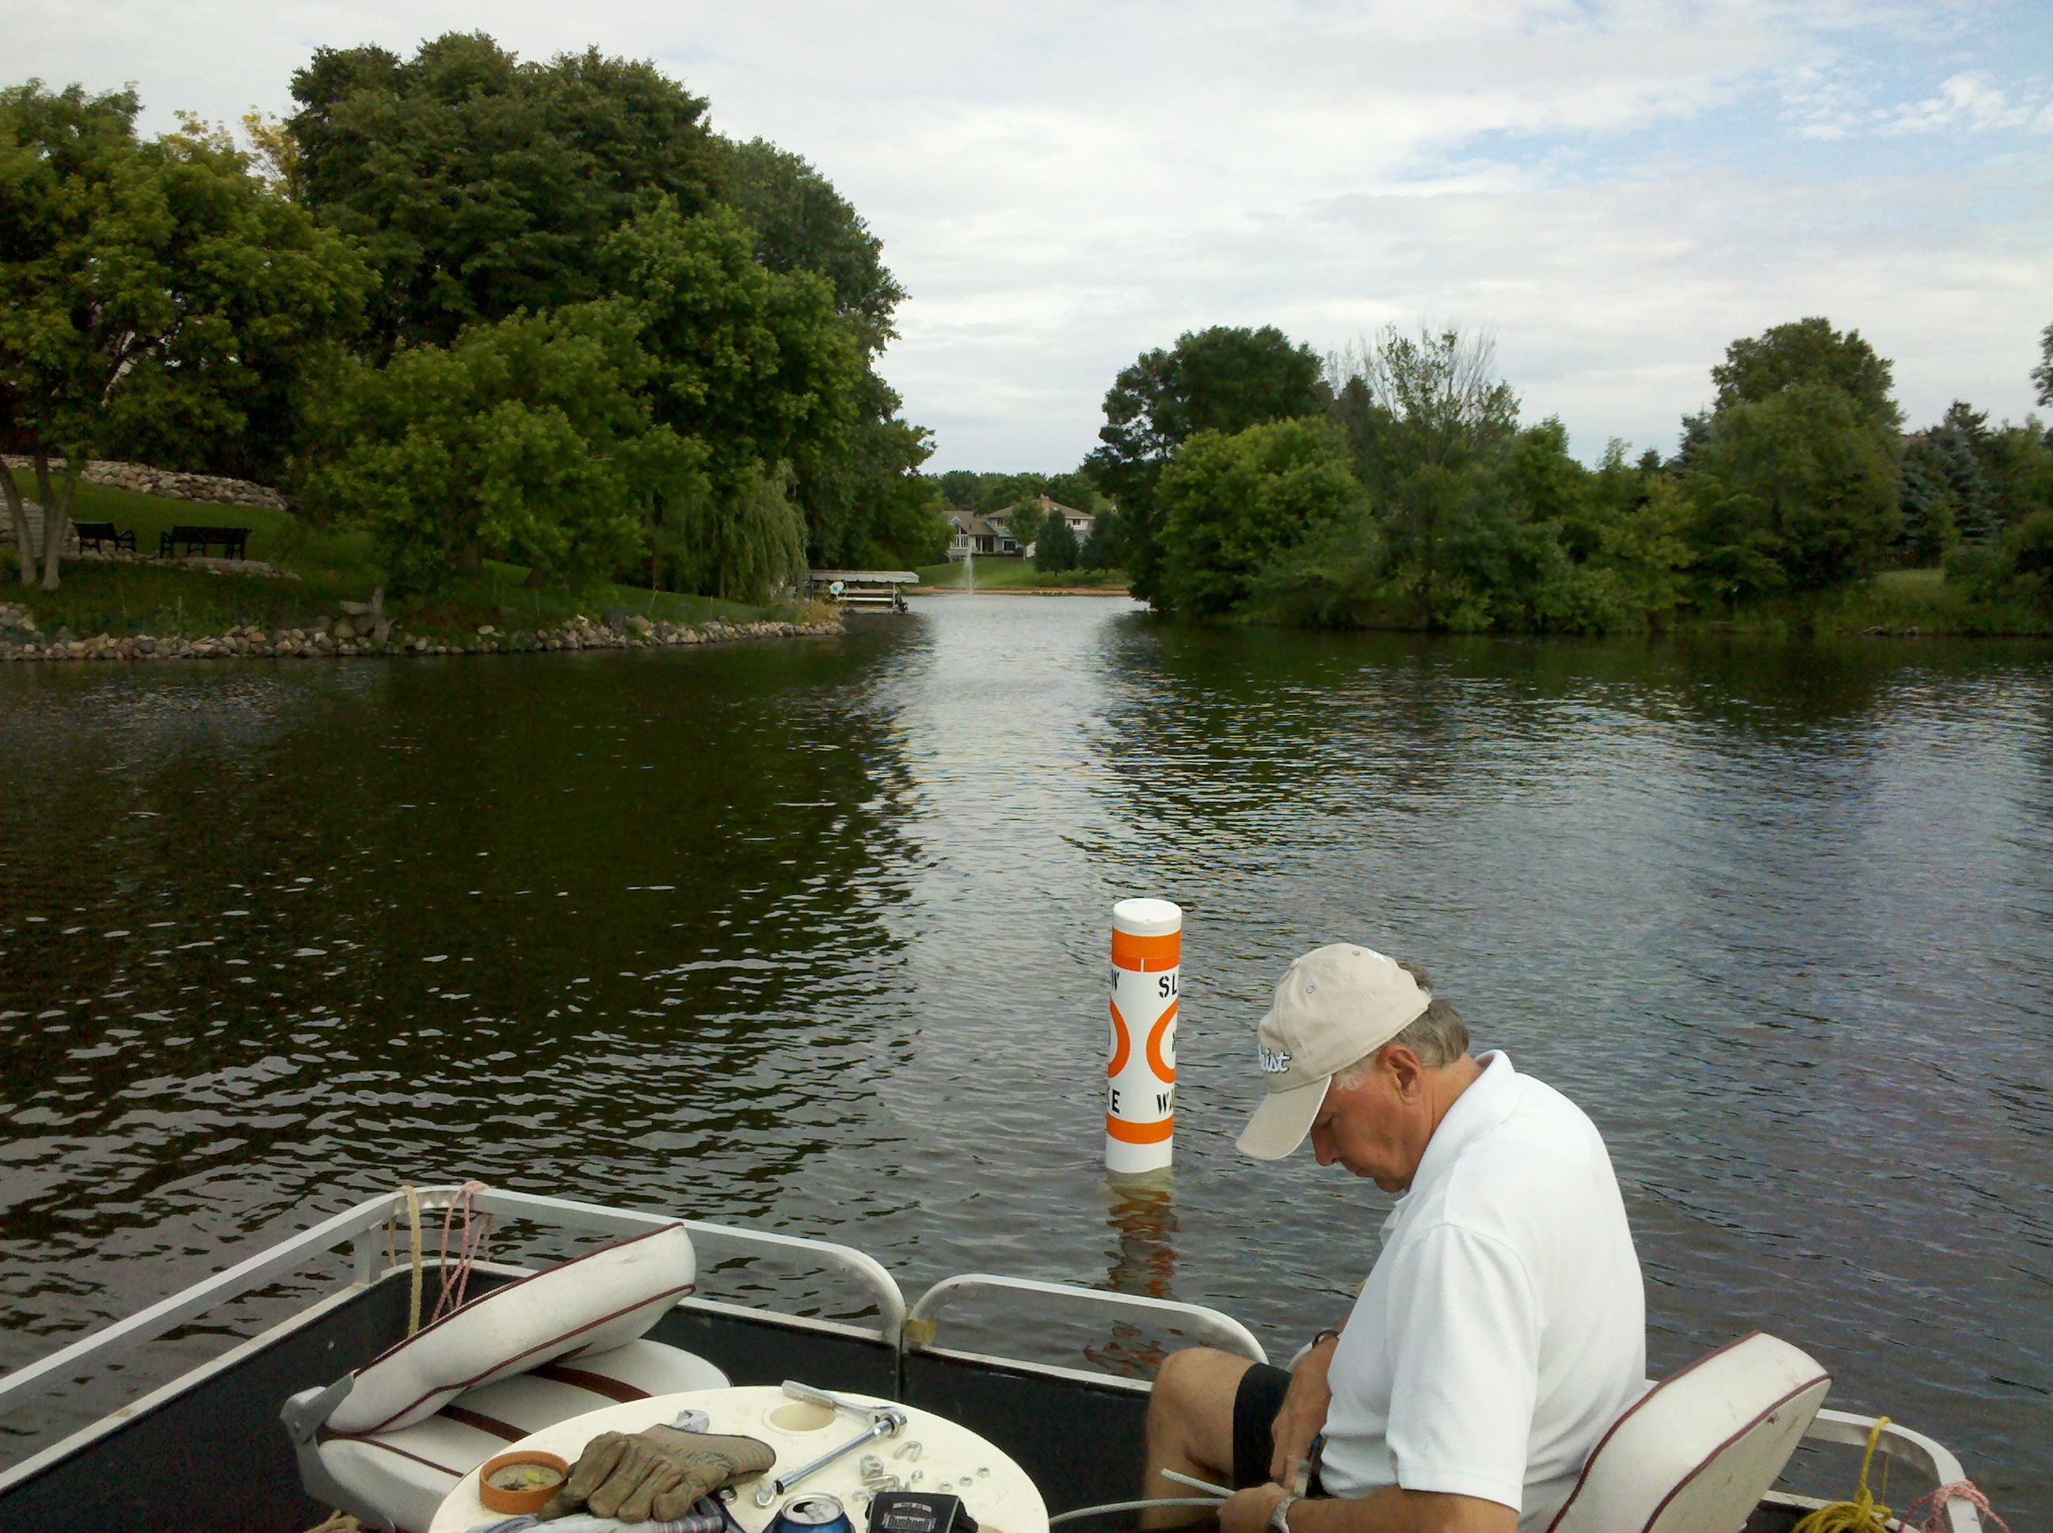
RLAA Financials (as of 10/19/11)

Assets
Total Assets $13,221

Recent 2011 Payments
Slow/No Wake Buoys $361.52
Dissolved Oxygen Meter $621.00

Potential 2012 Projects
Carp Removal $7,000
Dredge Channel $6,000
CLP Plant Survey $2,000
TOTAL (potential) $15,000

The RLAA Board of Directors would like to thank Larry Bick for his short, but productive, time of service as a board member. Larry resigned from the board this summer to concentrate on other priorities outside of RLAA.

Treasury Report

As of October 19th RLAA has $13,221.00 in funds. Year to date we have 46 paying members, with a total of $5,760 received in 2011.
Data from Treasurer Rick Stulac

Thanks to Scott Roeglin who provided this article.

The 'Green' Section

See separate insert from Gertens for preparing trees and shrubs for the winter.

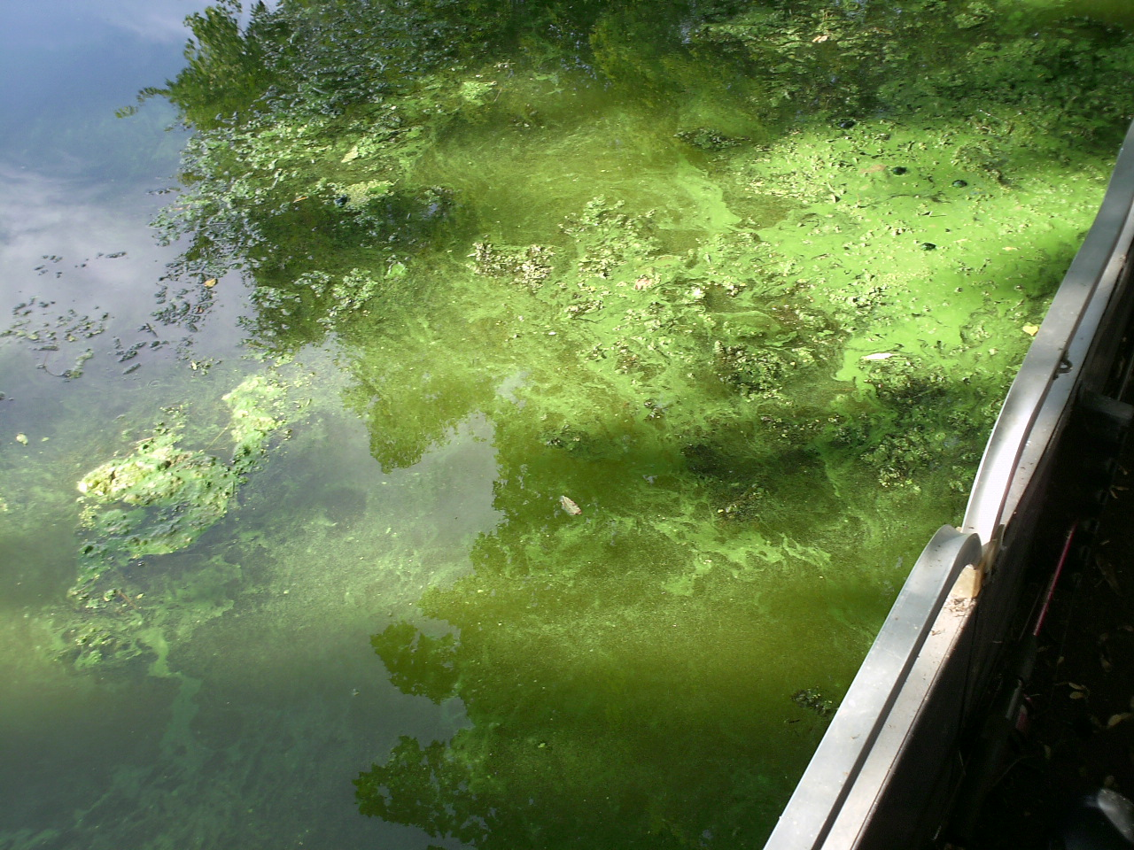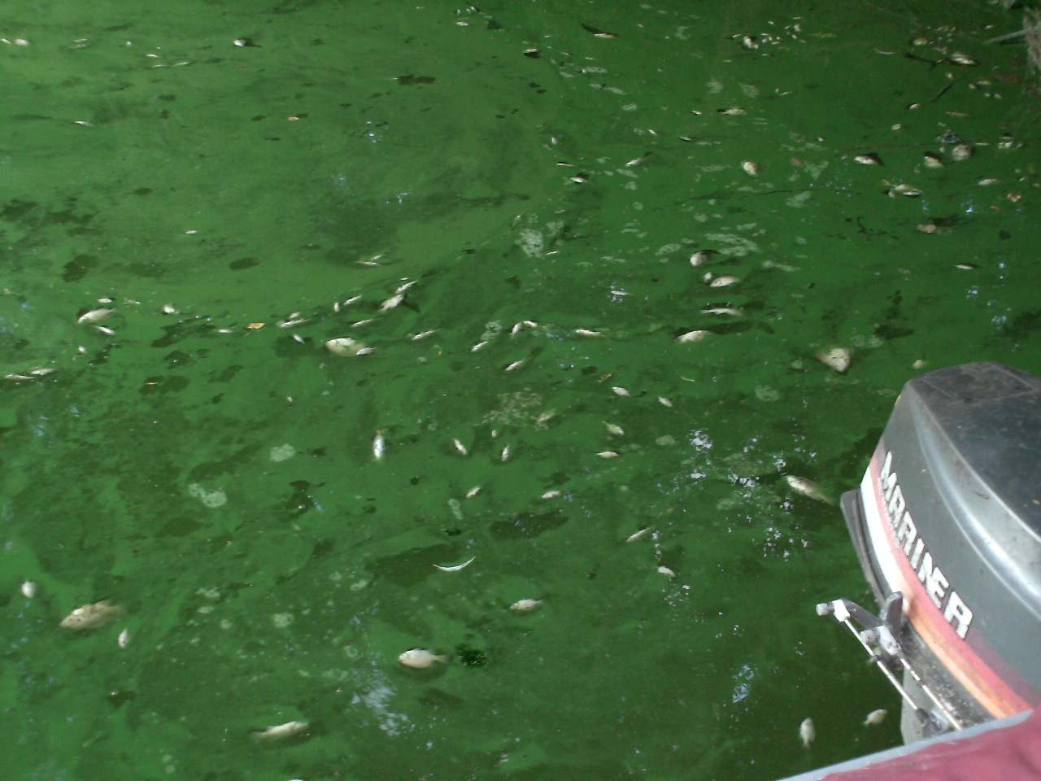
Elm Creek Fishkill (August 30-31)
In a small, confined area of Elm Creek (located south of County Road 30 and north of the Tristan Bay footbridge), many dead small and adult fish of various species were observed beginning August 30. Dissolved oxygen readings taken shortly before and after this time showed a rapid decrease in the level of oxygen required by fish to survive.
During this same time there was a heavy dosage of blue-green floating algae which become very concentrated in the entrance to the creek, which reduced sunlight into the water. By the 1st of September, this same area recovered with normal oxygen readings and the fish kill appeared to be over.

Aug 22 - Blue-green algae starts to cover surface.
Dissolved Oxygen levels later on Aug 27 were still very favorable to sustain fish life (7.03ppm at 1 meter down).
Aug 31 - Hundreds of dead fish of all species and sizes covered the surface since yesterday's die-off began. Dissolved Oxygen levels at this time were very low and unable to sustain any fish life (0.01ppm at 1 meter down).

Rice Lake 'Impaired Waters' Update

The Elm Creek Watershed TMDL plan is a 5-year project which began in 2009. Upon it's completion in 2014, the plan will require various governments and agencies to attain certain water quality goals. At that time, we would hope to see significant improvements in the water quality of our lake as those plans begin to become implemented.
The Stakeholders met 3 more times (April 20, August 23, and October 26) since the last meeting we covered in this newsletter back on January 20, 2011 at the City Hall in Plymouth. The project group is almost done with the data collection stage and is ready to begin moving forward into the Modeling stage, where the data is applied to the impaired target areas within the watershed.
You can also find out more information about the watershed and its related plans via these links:
TMDL Project Plan: http://ricelake.homestead.com/files/Elm_Creek_Watershed_TMDL_work_plan_2_4_09.pdf
Elm Creek Watershed (the website has been recently redesigned): http://elmcreekwatershed.org/
Rice Lake Management Plan: http://ricelake.homestead.com/files/Rice_Lake__27-0116__Management_Plan.mht

Weaver Lake - There was nothing to report for this edition. See website for other information at: http://www.wlca.org/
Fish Lake - There was nothing to report for this edition. See website for other information at: http://www.minnesotawaters.org/group/flara/welcome
Eagle Lake - Eagle Lake had above water depth all summer till September. Lake Weeds at the east and south were the worst when compared to the past few years. Lots of lake activity this summer by many new homeowners on Eagle Lake. Lake assoc sponsored Monday Family night on the lake and many homeowners and kids participated. For more info, visit http://eagle-lake.org/
Pike Lake -. There was nothing to report for this edition. See website for other information at: http://eagle-lake.org/
Cedar Island Lake - There was nothing to report for this edition. See website for other information at: http://c-vue.com/cedarisland.html
Edward Lake - There was nothing to report for this edition. See website for other information at:
Cook Lake - There was nothing to report for this edition.
Arbor Lakes - There was nothing to report for this edition.

A Glance at other local lake happenings

Rice Lake Area Association
Rice Lake Area Association
Attn: Rick Stulac
13870 95th Ave. North
Maple Grove, MN 55369

E-Mail: ricelakeassoc@comcast.net

RLAA Officers
Rick Stulac (Treasurer)
George Schneider (Secretary)

Board members
Wade Quale
Scott roeglin
Joy roeglin
bill kidder

New Members Update

We have new members/contributors to RLAA since our last edition released in February 2011:
- Lyle & Gail Shank
- Thomas & Laura Donnelly

RLAA Website Statistics
Have you visited our website lately at http://www.ricelakemn.com?
2011 Statistics (January 1, 2011 through October 31, 2011)
Number of visits to Home Page = 983
Number of visits to Projects page = 144
Number of visits to Events page = 171
Number of visits to Board Meetings page = 20
Number of visits to Board Info page = 86

For complete trend detail, go to our Site Statistics web page at:
http://ricelake.homestead.com/files/RL_Site_Visits_2011.mht

Newsletter Editor____
George Schneider
dukewolves@yahoo.com

We’re on the Web!
See us at:
http://www.ricelakemn.com/

Rice Lake Want Ads

For Sale: 1989 Ercoa 19' Pontoon with a 35HP Mercury Outboard. The trailer is a 1994 Ercoa 21' with 8' wide wheelbase. The boatlift is 1996 Vibo with a 9x24 canopy. Asking $6,000 for the pontoon, outboard and trailer, and $1,400 for the boatlift (canopy has a rip and needs repair). Call Chuck at 763-420-4721.

RLAA is a member of the Minnesota Waters organization (formerly known as Minnesota Lakes and Rivers Council). We are a non-profit organization. RLAA was formerly known as Rice Lake Homeowners Association, but changed names in the early 1980's when a new development took that name.

About Rice Lake Area Association…

