1st Quarter 2009
Rice Lake Newsletter

A non-profit organization serving the members of Rice Lake Area Association (RLAA)

RLAA Annual Meeting will be at 6:30 pm on Tuesday, May 5th at Sundance Golf & Bowl! Plan on attending this event to hear what we have done and our plans for 2009!
Please RSVP (e-mail - ricelakeassoc@comast.net or call Rick at 763-494-8467)

Special Interest Articles:

• For the Birds…

- RLAA Annual Meeting on May 5th

• Join one of our Task Teams if you are interested in one of these areas:
- Lake Management
- Fundraising
- Media
- Environmental

Individual Highlights:
Project Update 2
Treasury Report 2
Recreation page 2
Green Section 3
Rice Lake Facts 3
Other local lakes 4
Website stats 4
Contact Info 4
FOR THE BIRDS...

A thin ice still coats the lake. It’s 33 degrees, and Dennis is walking across the backyard in his waders. He’ll trek through the wetlands before entering the cold water to put out three wood duck houses. When we moved here in 1997, he was like a kid that came alive again. He enjoys the deer that pose for us at dawn and dusk, the beaver who swims from our wetlands to the small island and back again, but most of all, his attraction is to the birds.

This spring we are particularly excited. We know our wetlands are critical to promoting a bird habitat. The more effort Dennis makes to draw them here, the more variety of species we get. The bird migration north has provided a showcase of birds earlier this spring than we can remember. While I’m generally not the first one to pick up the binoculars, this is our third sighting of a pair of white tundra swans who seem to come only for a day. I can hardly take my eyes off of them. Their stature and elegance is holiness. A pair of wood ducks also arrived early, before the wood duck houses were installed. The unremarkably, plain, brown female perched on top of the post in the water looked up with an attitude as if to declare, “The closing and move in date was supposed to be in March!” So, Dennis is now marching out into the water following her orders. ...Nothing like a female with an attitude to motivate a man. The handsome, meticulously adorned, male wood duck swims below her, always close by, always in sight. With a twinkle in his eye, Dennis has reminded me that in the human world, the beauty in the sexes is reversed. Nice try, honey. O.K., ...now explain George Clooney.

While the geese and hooded merganser enter our small cove, two morning doves land on the fence post. These love birds are an inseparable pair. To a rookie bird watcher like me, theirs is the only identifiable sound amid the glorious harmony of birds singing. Just to close my eyes is to hear the music and rhythm of nature.

Gaining awareness, I realize how much time has passed while Dennis has supported his bird habitat and I have sat in the wings. I open my eyes to get up from my warm, porch table. It’s time to do something more productive. Suddenly, I see a pair of neighborhood bald eagles soaring into view and I think... just one more cup of coffee.

Thanks to RLAA Board Member Barbara-English Belanger for this article!

.

Xxxxxxxxxxx

xxxxxxxxxxxxxxxx

What's New with Rice Lake?

RLAA Task Team update

We now have two (2) Task Teams up and running and are in the process of organizing our 3rd team. See below for contacts for those teams and please reach out to them if you'd like to be part of these groups.

Membership Update

We would like to recognize these new
- Dale Weick
- Randy's Electric
Task Team Mission Statement Chairperson Phone
Media/Membership Promote and support RLAA Joni Stulac (temp) 494-8467
Lake Management Water Quality/Fisheries/etc George Schneider 420-8027
Environmental* Promote and educate Barbara English-Belanger 494-9399

* - The Fundraising and Media/Membership teams have been combined into one team.
members/contributors to RLAA since December 2008:
- Animal Wellness Center of Maple Grove
There will be 2 hired out projects conducted on Rice Lake this season - an Aquatic Plant Survey and sample sites running sonic algae treatment units.

Aquatic Plant Survey
Rice Lake has hired out the surveying to be conducted by Freshwater Scientific Services, a local Maple Grove company.

For the first time, the survey will include the West Bay (west of I-94), which has been experiencing a much different water quality environment than the East Bay during the past several years.

The survey will be conducted using a Point Intercept method, which is now a new requirement by the MN DNR.
Sonic Algae treatment ("algae busters")
The sonic algae units are electric (110 volt) apparatus which float on the surface of the water. They project sonic waves at a frequency that will only affect algae by breaking it down. The units have typically been used in smaller water bodies, such as ponds. There will be up to 3 sites run for a period of 4 months (May through August) to see how this treatment can reduce our algae blooms (check our website for updates on locations & results). The units will be rented with an option to own.

Some features of the sonic algae units include:
- Fish friendly
- Does not use chemicals
- Simple to install and operate
- Requires power but only a few watts
- Does not harm native plant growth
- Does not require DNR permit
- Units have 2 year warranty and estimated life expectancy of 8-10 years
- Technology has been around for approximately 6 years

Project Update

Rice Lake Survey Grid
Update by George Schneider

Sonic "Algae Buster"
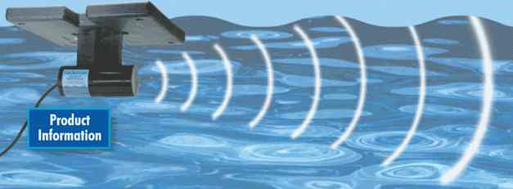
RLAA Financials (as of 4/1/09)

Assets
Checking $ 5,495.29
Savings $ 3,044.59
Total Assets $8,539.88

Upcoming Payments
Plant Survey $3,600.00
Sonic Algae $3,550.00
Insurance $750.00
Member stickers $250.00
Total payments $8,150.00
Less LIPs $3,550.00
RLAA Payments $4,650.00

Treasury Report

Ice Out
The ice was out on Rice Lake by Monday, March 30 this year, about 1 week earlier than last year.
Bird Action
See Page 1 of this newsletter for a spring summary of the wildlife on the west side of Rice Lake.
Fishing
Although it is still early for fishing this season, we have not heard of any reports of a winter fish kill this year, like we experienced last year when the ice broke. Time will tell if this means an increase if the fish population.
Some carp were spotted in late March running between Fish and Rice Lakes under the Weaver Lake Road culverts. In mid-April, carp have been seen jumping out of the water (although it is still early for their spawning season to begin).
Rice Lake Trails
The bike path is in good shape so far this spring. Feel free to enjoy the 3.4 mile excursion around the lake. There may be some trail resurfacing taking place later this season. More details will be given when we learn of them.

Outdoor Recreation Update

For the calendar year starting 5/1/2008 – 5/1/2009 the Rice Lake Area Association collected $6320.00 in member dues. Last year (1/1/2008) we raised the contribution rates to $125.00 for members that have water access (both Lakeshore and Creekside) and $60.00 for members with views ( http://www.ricelakemn.com/files/Rice_Lake_Area_Association_Membership.mht). We experienced a 32% increase in income over 2008 and a 16% increase in member participation with 56 paying members overall.

Last year we spent less money than we received for the first time in two years. The main reason for the net increase in income for the year was the lack of a $9,000.00 treatment of copper sulfate for temporary algae reduction. We were short on cash flow last year to pay for the algae treatment, based upon prior commitments for the Fish and Plant surveys.

Our mailing costs for last year were close to $500.00. We have over 100 e-mail addresses in our database today. If everyone that is receiving this newsletter via the postal system would be so kind as to send an e-mail to the following address. Please include your name, address, and preferred e-mail address ricelakeassoc@comcast.net

Visit http://www.sonicsolutionsllc.com/ for more info.
Update by Treasurer Rick Stulac

LAKESHORE EROSION AND BUFFER ZONES

In the past, we have briefly touched on both the need for buffer zones and also about erosion issues.

This month we are going to talk about how using the right elements in buffering zones, you can create excellent protection for your shoreline from erosion, as well as building a natural habitat for our fish and wildlife.

Many of you have seen along Rice Lake shoreline the most common type of technique for erosion stabilization call Rip rap (A hard-armor technique- rocks or concrete). If installed correctly this is a sufficient way to control erosion and helps with the run off. This type of erosion control can be expensive to install, and hard to install correctly and is not that attractive as some other methods that may be used in the right environment. There is a different method (a soft-armor technique) that uses organic and inorganic materials combined with plants to create a living barrier of protection. This is called Bioengineering, a method that provides erosion control through the use of live vegetation in addition to or in place of hard-armor. As you can imagine this method not only will look attractive to our eyes, it will be more natural, work as a great buffer and make a great habitat for our wildlife. Shrubs provide nesting sites for food for birds. Fish use the shade created by the shrubs and tall grasses near the water’s edge. Turtles love to sit and sun themselves in these areas. Bio-engineering does not require heavy equipment to construct and uses living material obtained nearby. It is less labor intensive and because it is alive, it repairs itself.

Wave breaking devices set out from shore beyond the planted areas is an excellent way to temporary act as a wave breaker. Some examples of materials to use for this are coconut-fiber logs, hardwood brush, rock within filter fabric, etc.

Please remember that with any type of stabilization technique that you are planning to install to check with your local Soil and Water conservation district office or DNR to help you choose the best technique and get the appropriate permits and plans to do the engineering work required.
For more information on these buffer and erosion systems please check out “Lakescaping for Wildlife and Water Quality” by the Nongame Wildlife Program – Section of Wildlife Minnesota DNR by Carrol L. Henderson, Carolyn J. Dindorf and Fred J. Rozumalski at your local library or bookstore.

Thanks to this month's contributor - Joni Stulac!

The 'Green' Section

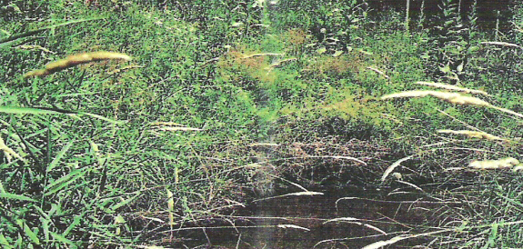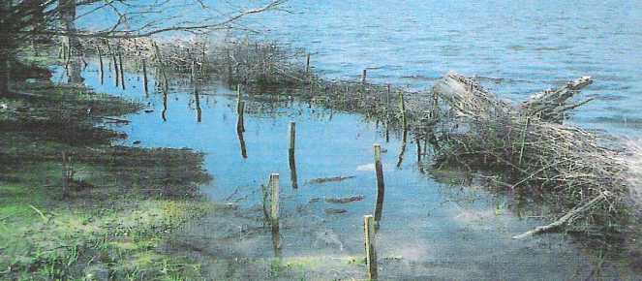
Brush mattress, willow and dogwood wattles and live stakes were used to stabilize this shoreline
Stabilize this shoreline.

Temporary wave breakers made of brush provide a calm area for plants to grow.

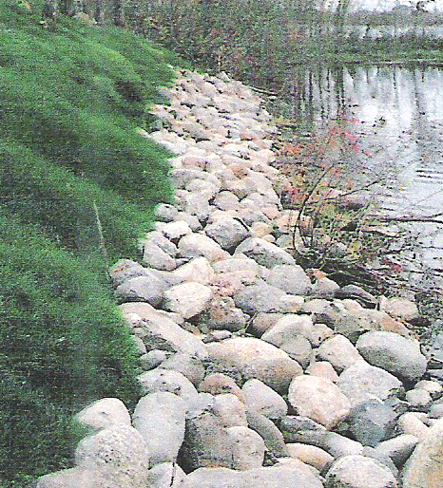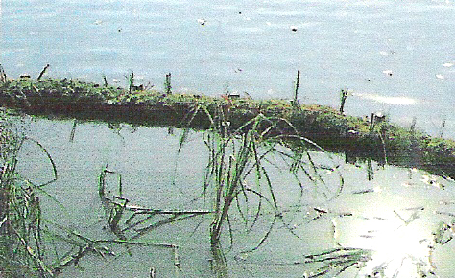
Rock Riprap eliminates habitat
A coconut-fiber roll is used as a wave breaker.

Rice Lake Facts

Did you know that Rice Lake…
- Is now recognized as having 2 bays (West Bay and East Bay)?
  - West is the area west of I-94 where Elm Creek enters (Boston Scientific side)
  - East is the area east of I-94 bridge (right hand side when driving Westbound on I-94)
- No winterkill has been observed for this past winter (we did lose a lot of fish to last winter's fish kill)

Weaver Lake - Planning on partial chemical treatment for Curlyleaf Pondweed (CLP) in 2009.
Fish Lake - Nothing to report.
Eagle Lake - Applying Iron Filing treatment to help stop CLP growth.
Pike Lake - Also conducting test areas for Iron Filing treatments with Eagle Lake.
Cedar Island Lake - Planning entire lake fish kill to remove rough fish and restock.
Edward Lake - No fish kill was observed this year.
Cook Lake - Nothing to report.
Arbor Lakes - Was recently announced as having Eurasian Watermilfoil in it and is on the Impaired List maintained by the MPCA.

Rice Lake Area Association
Rice Lake Area Association
Attn: Rick Stulac
13870 95th Ave. North
Maple Grove, MN 55369

E-Mail: ricelakeassoc@comcast.net

RLAA Officers
Eric Lind (President)
Jim Kridel (Vice president)
Rick Stulac (Treasurer)
George Schneider (Secretary)

Board members
Molly Kridel
Wade Quale
Nika Rybinski
joni stulac
Barbara English-Belanger

A Glance at other local lake happenings

Media Update
Board Member recruiting
We presently have 9 Board Members with plenty of room to add more, so please feel free to apply if you have any of these valuable skills:
- Fundraising
- Water Quality knowledge
- Environmental background

You can reach us at ricelakeassoc@comcast.net. We would love to have more members on board!

RLAA Website Statistics

We have added a new domain name for our website - the new URL is http://www.ricelakemn.com. The old URL (http://ricelake.homestead.com) will continue working.

We are currently in the process of redoing our website. The new website will be better organized and easier to navigate. Stay tuned for details as we begin to work on this project.

About Rice Lake Area Association…
Newsletter Editor____
George Schneider
dukewolves@yahoo.com

RLAA is a member of the Minnesota Waters organization (formerly known as Minnesota Lakes and Rivers Council). We are a non-profit organization.
RLAA was formerly known as Rice Lake Homeowners Association, but changed names in the early 1980's when a new development took that name.
We’re on the Web!
See us at:
http://www.ricelakemn.com/

Company Name
Street Address
City, ST 22134
Rice Lake Area Association
Attn: Rick Stulac
13870 95th Ave. North
Maple Grove, MN 55369

