

**RLAA 2012 Annual Meeting Summary**

*The RLAA 2012 Annual Meeting was held on Tuesday, May 1 at Sundance Golf & Bowl. 21 residences were represented at the event. After board member and resident introductions were completed, Jeff Monk from Maple Grove gave a presentation on his dock & lift business to offer his services to anyone in the association. Treasurer Rick Stulac presented the 2011 financials and 2012 budget, showing that 2011 revenue was 12% higher than in 2010. Total RLAA assets as of May 1, 2012 stand at $12,021.33.*

*A lake review of 2011 and plan for 2012 was given by the secretary George Schneider, emphasizing the need to increase the “good” plant population and reduce the “bad” plant population. Projects completed in 2011 included: Dissolved oxygen meter purchase to track O2 levels throughout the year; Installed 3 ‘Slow/No Wake’ buoys to remind boaters to protect the shoreline; and the continued efforts to monitor water quality by sampling with the Minnesota Pollution Control Agency. Projects postponed in 2011 included: Carp removal (lack of commitment from the area commercial fisherman) and Channel dredging (did not achieve 100% resident approval). A review of the drawdown process was also presented.*

*Rich Brasch, Manager of Water Resources for Three Rivers Park District, presented an update for the Elm Creek Watershed TMDL project, which is in year 3 of the 5 year plan. Project is now in the Data Analysis and Modeling stage. Next steps will be to access ownership to municipalities for financial obligations to achieve targeted water quality goals.*

*Fish Lake resident Curt Cich requested access to Rice Lake at various times during the fishing season to hunt for carp by bow-fishing. Those present at the meeting welcomed him to the challenge.*

*Board Member elections were conducted with incumbents Rick Stulac, Bill Kidder and Scott Roeglin returning for 3-year terms.*

*Drawings were run by Scott & Joy Roeglin with the top prize of an IPad2 being awarded to the Tim George household. Other prizes awarded included: Weed Eater, Sheraton motel stay, and many gift certificates from local businesses, many of which were donated.*

**Fall 2012**

Rice Lake Newsletter

A non-profit organization serving the members of Rice Lake Area Association (RLAA)

***Special Interest Articles:***

* 2012 Annual Meeting
* Thank you Members!
* Project Update: Weed & Algae in 2012
* Elm Creek TMDL update
* The Green Section

**RLAA Member Appreciation**

We would like to extend a big 'Thank You' to those of you who have helped support RLAA by paying your association dues in 2012. Your contributions and participation in the association help us reach our project goals for improving the quality of the lake and surrounding area.

|  |  |  |  |
| --- | --- | --- | --- |
| Mark & Lori | Ellingson | Marshall & Lisa | Alsaker |
| Joe & Susie | Liedl | Jim & Molly | Kridel |
| Shane & Enid | Mason | Scott & Joy | Roeglin |
| Peter & Sharon | Raatikka | Dan & Sue | Hanson |
| Allan & Pat | Chan | Tom & Leann | Cross |
| Mark & Jean | Pogemiller | Bill & Marie | Kidder |
| Daniel & Betsy | Salzar | Don & Biddy | Waletzko |
| Bob & Stacy | Cremers | Bobbi & Joe | Kiemen |
| Russ & Nika | Rybinski | Cheryl | Flegel |
| Gary & Shawna | Shubinsky | Jerry & Mary | Yunger |
| Paul & Keeley | Ray | Tim & Denise | Zastoupil |
| Mark & Leslie | Davison | Randy & Leanne | Forbrook |
| Robert & Amber | Shimpa | Bob & Sue | Drag |
| Jeff & MaryEllen | Swanson | Sheila Ann | Carey |
| Richard & Linda | Hibbard | Richard & Joni | Stulac |
| Jim & Anne Marie | Seward | George & Jana | Schneider |
| Tristan Bay Assoc. |  | Jim & Carol | Malone |
| Marlin & Sarah | Grose | Chuck & Pat | Berger |
| Tom | Dechmann |
|  |  |

**Next Board Meeting**

When:

(To be determined)

Where: Maple Grove Library

*Visit our website for agenda and please RSVP your attendance!*

***Individual Highlights:***

PROJECT UPDATE 2

TREASURY REPORT 2

GREEN SECTION 3

FEATURE ARTICLE 3

OTHER LOCAL LAKES 4

WEBSITE STATS 4

WANT ADS 4

CONTACT INFO 4

Since our last media communication (the 2012 Annual Meeting Minutes), RLAA has completed one project to conduct an aquatic plant survey to measure the level of weeds (good & bad) in the lake/creek. See below for details.

## Project Update

**2012 Plant Update**

A formal aquatic plant survey was conducted in June this year by James Johnson of Freshwater Scientific Services. Results were presented to the RLAA board in August with no major surprises. Although non-native growth of Curlyleaf Pondweed has increased since last year, the recommendation was to not pursue a drawdown to attempt to reduce this growth next year by freezing out the seedlings over the winter months. The location of CLP tends to be in <6’ of water. Native vegetation is also showing an increase in growth with Coontail being the dominant plant.

Vegetation in the West Bay also continued to be very heavy, at times reducing navigation west of the I-94 highway bridge to Elm Creek. Local residents needed to rake or cut the plants to create a channel for access to and from the lake.

As many of you probably noticed during this past year, the levels of noxious algae were lower than usual. Although there does not seem to be a specific reason for this reduction in look and smell of the water, this did help make the outdoor season more enjoyable this year.

**2012 Dissolved Oxygen Readings**

(Details and accompanying graphs will occupy this portion of the Projects area.)

*For more info, visit RLAA Website 'Other Activities' page at this link:* [*http://ricelake.homestead.com*](http://ricelake.homestead.com)

*Update by George Schneider*

*The RLAA Board of Directors would like to thank Joy Roeglin for her time of service as a board member. Joy resigned from the board this summer to concentrate on other priorities outside of RLAA.*



## Treasury Report

**RLAA Committees/Task Teams seek more members!!**

Join one of our association committees and help determine the future of our lake/creek.

* Membership Team
* Lake Management Team
* Environmental Team

If you would like to be a part of one of these teams, contact us at [RiceLakeAssoc@comcast.net](mailto:RiceLakeAssoc@comcast.net).

*Data from Treasurer Rick Stulac*

For 2012 we have 38 paying members with a total of $4,735 in dues paid.  Our total paid dues is down $1,000 from last year.   After paying $2,000.00 for the 2012 aquatic plant survey we have $14,633.85 in the bank.

The Elm Creek Watershed TMDL plan is a 5-year project which began in 2009. Upon it's completion in 2014, the plan will require various governments and agencies to attain certain water quality goals. At that time, we would hope to see significant improvements in the water quality of our lake as those plans begin to become implemented.

Project manager expects to have entire watershed mapped out by early 2013 for which areas are to be addressed which are listed on the impaired list. Rice Lake will have sediment core testing done during the Fall of 2012 to help determine how much nutrient loading is coming from internal (within the lake) vs. external (outside of the lake).

You can also find out more information about the watershed and its related plans via these links:

TMDL Project Plan: <http://ricelake.homestead.com/files/Elm_Creek_Watershed_TMDL_work_plan_2_4_09.pdf>

Elm Creek Watershed (the website has been recently redesigned): <http://elmcreekwatershed.org/>

Rice Lake Management Plan: <http://ricelake.homestead.com/files/Rice_Lake__27-0116__Management_Plan.mht>

## Rice Lake 'Impaired Waters' Update

RLAA Financials *(as of 10/31/12)*

**Assets**

Total Assets  **$14,633.85**

**Recent 2012 Payments**

Aquatic Plant Survey **$2,000**

**Potential 2013 Projects**

Carp Removal **$7,000**

Dredge Channel **$6,000**

TOTAL (potential) **$13,000**

The Bald Eagle

Of the many beautiful birds on Rice Lake, the majestic Bald Eagle is one of the most impressive and Rice Lake is home to several. We can always count on one or two soaring over our boat when out for an evening ride. The “teenage” ones are so fun to watch with their immature antics, as they learn how to coordinate their huge wings and strong talons. We had one try to land in a large maple tree in our backyard on Elm Creek last year. He had a big ole bullhead in one talon and was trying to hang on to the branch with the other. His strong, broad wings kept hitting the other branches as he struggled to keep his balance, but there was no way he was going to drop his prize. He sure gave me a chuckle that day.

The bald eagle, our nation’s symbol since 1782, is the second largest bird of prey, with a wingspan of 6-8 feet. The pure white head and tail and contrasting dark brown body of adult bald eagles are easy to identify. Immature or juvenile bald eagles are more difficult to identify, as their head and tail are brown or mottled brown and white. The blotchy white coloration on the underside of the wings and tail of young bald eagles can be seen in flight. Bald eagles don’t attain full adult plumage, with the sharp beak turning its distinct yellow color, until their fourth or fifth year of life. Males and females have the same coloring, with the female being about 25 % larger than the male. They typically weigh between 9-14 lbs and have 7,000 feathers, which help keep them cool in the summer and warm in the winter. They don’t need to migrate to warmer weather like many of us do; they just need to have an open water source for catching their favorite dinner, fish. Bald Eagles can fly to altitudes of 10,000 feet and during level flight they can fly 35 miles an hour, while being able to attain speeds of an amazing 50 miles an hour. They can live 20-30 years in the wild and with love and attention, up to 50 years in captivity.

Whether boating or walking, take time to go on a nature excursion this fall, around Rice Lake and down Elm creek. Although most of the great “white” egrets and their relatives the great blue herons are already heading south for the winter. The lists of things you may see are many, including beautiful fall color in the leaves, deer, fox, beaver, eagles, white trumpeter swans, canadian geese, cormorants, and a variety of other interesting birds not often seen here, as they migrate through Maple Grove on their southern journeys.

Credits:

"American Bald Eagle Description." *American Bald Eagle Description*. N.p., n.d. Web. 29 Sept. 2012. <http://www.baldeagleinfo.com/eagle/eagle8.html>

"Species Profile: Minnesota DNR." *Species Profile: Minnesota DNR*. N.p., n.d. Web. 29 Sept. 2012. <http://www.dnr.state.mn.us/rsg/profile.html?action=elementDetail>

Vanner, Michael. *A Field Guide to the Birds of North America*. Bath: Parragon, 2006. Print.

**The 'Green' Section**

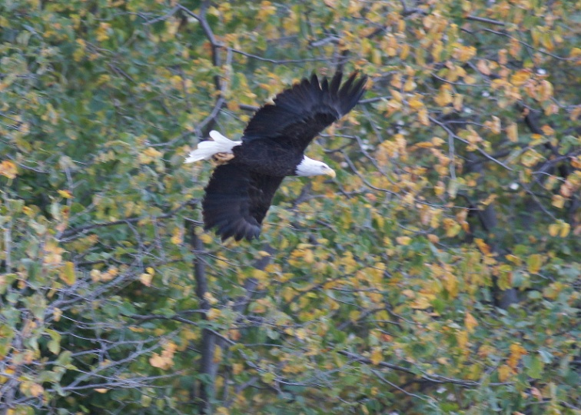 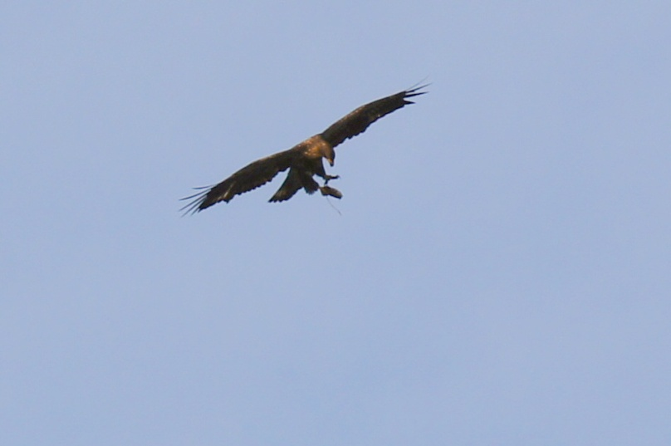

Thanks to RLAA member Joy Roeglin for writing this article and taking these photos.

Weaver Lake – See website for other information at: <http://www.wlca.org/>

Fish Lake - See website at: <http://www.minnesotawaters.org/group/flara/welcome>

Eagle Lake - In response to the TMDL's findings that External Load is a significant factor in Eagle and

Pike Lakes' impairment, the Eagle Lake Preservation Association Board is focusing on storm water

Run-off. We found that an "Adopt a Storm Drain" Program would be an effective way to address the

issues of Water Quality and Education, while bringing the community together to promote good

stewardship of our lakes.

Although there are a number of towns, cities, and watersheds throughout the country that have

encouraged adoptions and conducted "Adopt a Storm Drain" campaigns, we found no active programs

in MN. So we're excited as we launch this program. To kick off our Adoption Program, 38 storm drains

were adopted at our 2nd annual Eagle Lake Preservation Association Fall Festival. . See website for

other information at: <http://eagle-lake.org/>

Pike Lake - See website for other information at: <http://eagle-lake.org/>

Cedar Island Lake - See website for other information at: <http://c-vue.com/cedarisland.html>

Edward Lake – No update at this time.

Cook Lake – No update as of this time.

Arbor Lakes - No update as of this time.

General Lakes update - Rice Lake is at its lowest level (890.08) for this time of year since continuous records

began in 1988 (drought year) not counting the drawdown years. It is about 10 inches below the average

level (890.92) for this time of year. Maple Grove lake levels have been falling about 1 inch per week for

3 months with the lack of rain.

## New Members Update

We have new members/contributors to RLAA since our last edition released in Fall 2011:

* Tom & Leann Cross
* Dan & Betsy Salzer
* Sheila Ann Carey

**Newsletter Editor____**

George Schneider

[dukewolves@yahoo.com](mailto:dukewolves@yahoo.com)

##### RLAA Website Statistics

Have you visited our website lately at <http://www.ricelakemn.com>?

2012 Statistics (January 1, 2012 through September 30, 2012)

Number of visits to Home Page = 915

Number of visits to Projects page = 113

Number of visits to Events page = 130

Number of visits to Board Meetings page = 3

Number of visits to Board Info page = 96

For complete trend detail, go to our Site Statistics web page at:

<http://ricelake.homestead.com/files/RL_Site_Visits_2012.mht>

## A Glance at other local lake happenings

##### Rice Lake Area Association

Rice Lake Area Association

Attn: Rick Stulac

13870 95th Ave. North

Maple Grove, MN 55369

E-Mail: [ricelakeassoc@comcast.net](mailto:ricelakeassoc@comcast.net)

RLAA Officers

Rick Stulac (Treasurer)

George Schneider (Secretary)

Board members

Luke Johnson

Scott roeglin

Mark Ellingson

bill kidder

We’re on the Web!

*See us at:*

[**http://www.ricelakemn.com/**](http://www.ricelakemn.com/)

## Rice Lake Want Ads

If you would like to list something for sale to the members of the lake association, please send in your information to us at [ricelakeassoc@comcast.net](mailto:ricelakeassoc@comcast.net).

#### About Rice Lake Area Association…

RLAA is a member of the Minnesota Waters & Conserve Minnesota organization (formerly known as Minnesota Waters through May 2012). We are a non-profit organization. RLAA was formerly known as Rice Lake Homeowners Association, but changed names in the early 1980's when a new development took that name.